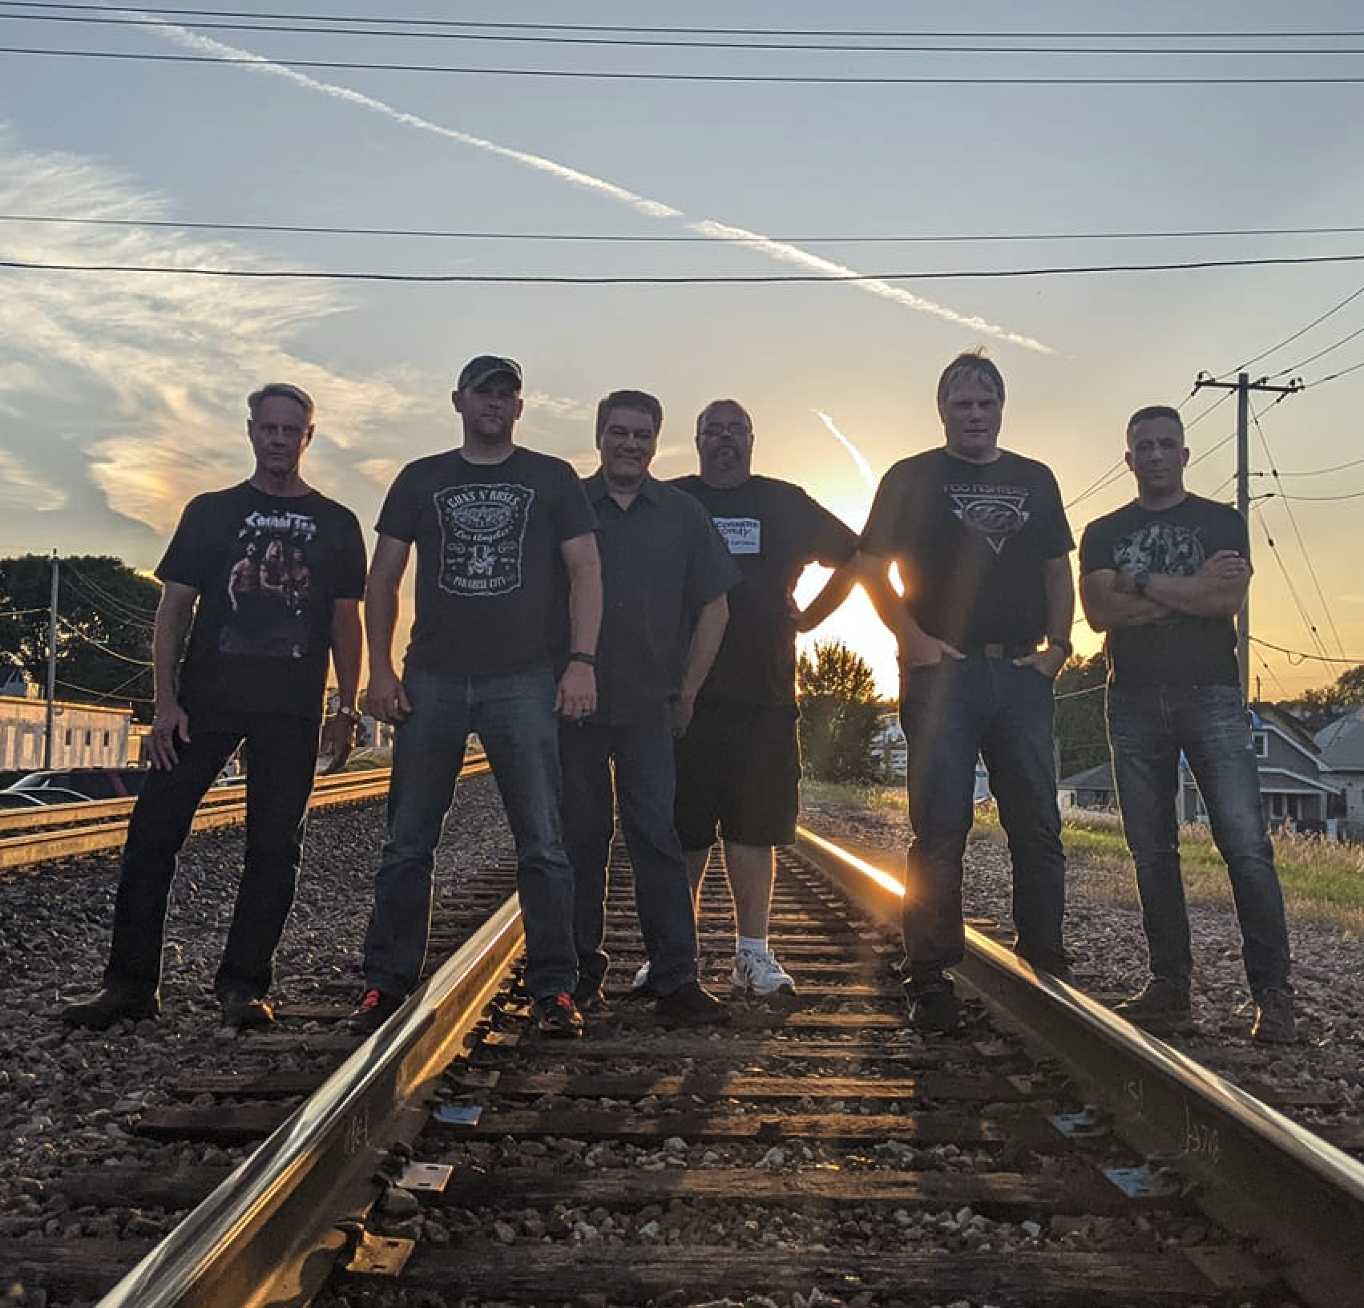 |  | Wasted  Talent  ROCK COVER BAND
Profile  Wasted Talent has been making music together since the 90's in some way, some way, shape or form. We play music that rocks...and we don't like to stick to a particular genre or era...70's, 80's, 90's, current....60's even?....we play what rocks, what's fun, and what will get people moving (and drinking). We're not in it for the $$$...so we don't play very often....so when we do make it out, our friends, family and fans show up in droves.  Artists Covered  Tom Petty, Foo Fighters, Sweet, Chris Stapleton, The Black Keys, Eagles, Van Halen, Bad Finger, Elvis, Cheap Trick, Jet, Collective Soul, Thin Lizzy, Violent Femmes, Poison…and MANY MORE!  Contact  WEBSITE:  https://wastedtalent.rocks  FACEBOOK:  facebook.com/WastedTalentMKE  Hobbies  Basket Weaving  Goat Herding  Malarky  Shenanigans  Guitar |  | WORK EXPERIENCE  SoLu Estate Winery - Band  June 2021 - Present  We play at least once a year at one of the Midwest's premier outdoor, live music venues. We're a crowd (and owner) favorite!  Slinger Community Beer Garden – Band  June 2020 - Present  Annual entertainer (often multiple dates per year) at this lovely outdoor venue...beer gardens are our jam.  Charcoal Grill Stage – WI State Fair - Band  August 2010  Graced the Charcoal Grille stage at Wisconsin State Fair THREE DATES.  Desert Inn, Las Vegas, NV - Greeter  June 2007  Additional Past Venues  Dundee Roadhouse. The Cactus Club. New Berlin VWF. Club Geribaldi. Liquid Johnny's. Paulo's Pizza. Milwaukee County Zoo. The Pettit Ice Center. Sue's Bay View Bandwagon. Dopp's Bar and Grill. Wanaki Golf Course Clubhouse. West Bend VFW. The Commodore. Fifth Ward Pub. Fritz's Pub. Harley's 100th Festival. Suburban Motors (Harley). Biloba Brewing Company. Slinger Community Beer Garden. Long Wong's. Private Parties.  SKILLS

